WORK ZONE PROGRAMMATIC REVIEW TEMPLATE
A work zone programmatic review is a data-driven, systematic, and holistic analysis that uses quantitative and qualitative data from different sources to assess the safety and mobility performance of work zones under a State's jurisdiction in order to identify improvements to that agency's work zone processes and procedures.

Disclaimer
This Work Zone Programmatic Review template is provided solely as a reference document to illustrate one possible approach for organizing and presenting information in a work zone programmatic review report. It is not intended to prescribe a required format or level of detail. Agencies are not required to follow the structure, content, or organization presented in this work zone programmatic review Template and are under no obligation to adopt or replicate it. The examples provided are for illustrative purposes and are not intended to prescribe data requirements. Each agency is encouraged to tailor its work zone programmatic review report to reflect its own data availability, priorities, practices, and review objectives using the format and level of detail that best support its work zone management goals.

Table Of Contents
1. EXECUTIVE SUMMARY (Optional) 49
2. INTRODUCTION/BACKGROUND 49
3. WORK ZONE PROGRAMMATIC REVIEW TEAM MEMBERS 49
4. ACTIONS TAKEN SINCE THE PREVIOUS WORK ZONE PROGRAMMATIC REVIEW 49
4.1. Follow-Up from Action Items 49
4.2. Other Efforts to Improve Work Zone Safety and Mobility 50
5. WORK ZONE SAFETY AND MOBILITY PERFORMANCE 50
5.1 Summary of Annual Work Zone Performance Trends 50
5.2 Data-Driven Work Zone Safety and Mobility Performance Assessment 52
6. PROGRAMMATIC ASSESSMENT OF WORK ZONE PROCESSES AND PROCEDURES 57
7. SUMMARY OF ALL FINDINGS AND ACTION ITEMS 58
8. APPENDICES (Optional) 59
APPENDIX A.1 – EXAMPLE PERFORMANCE ANALYSIS GRAPHS AND CHARTS 60

List of Figures
Figure 1. Graphic. Number of work zone miles. 60
Figure 2. Graphic. Number of work zone projects. 60
Figure 3. Graphic. Work zone VMT. 61
Figure 4. Graphic. Number of work zone crashes per thousand work zone miles. 61
Figure 5. Graphic. Number of work zone crashes caused by speeding and distracted driving. 62
Figure 6. Graphic. Work zone fatalities per billion dollars of transportation capital outlay. 62
Figure 7. Graphic. Average work zone queue length at significant projects. 63
Figure 8. Graphic. Queue length distribution at significant projects. 63
Figure 9. Graphic. Vehicle hours of delay. 64
Figure 10. Graphic. Number of notices from work zone field inspections and resulting corrections. 64
Figure 11. Graphic. Number of patrols in work zones. 65
Figure 12. Graphic. Number of enforcement hours in work zones. 65

List of Tables
Table 1. Example format for list of work zone programmatic review team members. 49
Table 2. Example format for summary update and assessment of the results of action items from a previous work zone programmatic review. 49
Table 3. Example exposure data and potential sources for exposure data. 51
Table 4. Example format for showing work zone safety performance trends. 51
Table 5. Example format for showing work zone mobility performance trends. 52
Table 6. Example format for list of representative projects. 53
Table 7. Example safety data and potential sources for safety data. 53
Table 8. Example mobility data and potential sources for mobility data. 54
Table 9. Example format for summarizing findings and action items. 58
Table 10. Work zone traffic control strategies receiving an Exceptional or Acceptable rating for more than X% of field reviews. 66
Table 11. Work zone traffic control strategies receiving an Exceptional or Acceptable rating for more than X% of field reviews. 66
Table 12. Annual TMP compliance audit by month of the year. 66
Table 13. Annual TMP compliance audit by project type. 67

1. EXECUTIVE SUMMARY (Optional)
This section is a short summary of the review process, findings, conclusions, recommendations, and action items.

2. INTRODUCTION/BACKGROUND
This section is a short introduction summarizing the State’s policy application/implementation of the Work Zone Programmatic Review requirement, review period covered, work zone safety and mobility performance measures used, key focus areas, review approach, and any other pertinent background information.

3. WORK ZONE PROGRAMMATIC REVIEW TEAM MEMBERS
This is a list of all stakeholders from the State divisions/offices that participated in the work zone programmatic review. This may include but is not limited to planning, safety, design, construction/implementation, maintenance, traffic engineering/operations, permitting, training, public information, FHWA Division Office, and consultants. An example format is shown in Table 1.
Table 1. Example format for list of work zone programmatic review team members.
No. | Name | Office / Division / Organization | Title / Designation | Email

4. ACTIONS TAKEN SINCE THE PREVIOUS WORK ZONE PROGRAMMATIC REVIEW
This section summarizes actions taken since the previous work zone programmatic review, including progress on previously identified action items and other initiatives undertaken to improve work zone safety and mobility.

4.1. Follow-Up from Action Items
This section contains a summary update and assessment of the results of the action items from the previous work zone programmatic review and any pending items that are still relevant to address. An example format for this information is shown in table 2.
Table 2. Example format for summary update and assessment of the results of action items from a previous work zone programmatic review.
Year | Targeted Issue | Action Item / Status | Responsible Office | Implementation Notes | Metric Selected | Metric Before | Metric After
2025 | Safety: Work Zone Speeding | Increase enforcement in work zone sites with high speeding violations. Status: Completed | Traffic Operations | Coordinated with State and local law enforcement to implement the change. Implemented work zone speeding cameras in critical work zones/highway sections. | # of speeding violations/100,000 work zone hours | X₁ | Y₁
 |  |  |  |  | % of travelers above speed limit | X₂% | Y₂%
2024 | Safety: Work Zone Intrusion Crashes | Increase consideration of Positive Protection for high-risk work zones that place workers close to traffic.  Status: Completed. | Design | Released a Design supplement that requires all project engineers to analyze the requirement of positive protection for every work zone activity and assign a score. If the score meets a threshold, the project engineers need to include positive protection strategies (e.g., speed barriers, concrete barriers, impact attenuators, buffer lanes) in the work zone design. | % of work zone projects with positive protection specified during design | X₃% | Y₃%
 |  |  |  |  | # work zone intrusion crashes over total work zone projects | X₄ | Y₄

4.2. Other Efforts to Improve Work Zone Safety and Mobility
May provide a summary/mention of any other broader efforts (e.g., new safety management program, new mobility performance analysis system) that had work zone management implications.

5. WORK ZONE SAFETY AND MOBILITY PERFORMANCE
This section encompasses an overview of work zone safety and mobility performance trends and the data-driven assessment conducted as part of the work zone programmatic review.

5.1 Summary of Annual Work Zone Performance Trends
This section provides a high-level summary of the State’s work zone safety and mobility performance trends over the reporting period (i.e., 5 years) using the data from the State’s annual performance monitoring efforts. The annual performance monitoring efforts are intended to be used for year-to-year continuous improvement and to identify and address any work zone performance issues on an ongoing basis.
Available crash data, available safety surrogate data, available operational data, and the performance measures specified in the State’s work zone policy are used in this annual performance monitoring. The data may be presented in text summary form, graphs, or tables representing statewide trends.
- Examples of crash data include fatalities, injuries, and crashes; examples of safety surrogate data include speed differentials, hard braking, and other data from connected and autonomous vehicles.
- Examples of available operational data include speeds, travel times, queue length, and duration.
- Examples of available exposure data include number of projects, number and length of lane closures, and vehicle miles traveled (VMT) through work zones.
Exposure Data
Work zone exposure data provide information about the scale and extent of the State’s work zone program. When tracked consistently, exposure metrics provide critical information for setting benchmarks and context around work zone performance. Examples of exposure data and potential sources for exposure data are shown in table 3. See appendix A for examples of charts showing work zone exposure trends over time.
Table 3. Example exposure data and potential sources for exposure data.
Exposure Data | Potential Data Source(s)
Completed Work Zone Miles | Agency logs, contractor logs, databases, field detector / probe data
Planned Work Zone Miles
Actual Work Zone Hours
Planned Work Zone Hours
Active Work Zone days
Total Work Zone Days Available
Work Zone Worker Hours
Lane Closure Hours - Daytime
Lane Closure Hours - Nighttime
Work Zone Projects
Work Zone Vehicle Miles Traveled

Safety Data
Table 4 provides an example format for showing work zone safety performance trends.
Table 4. Example format for showing work zone safety performance trends.
Year | Total Work Zone Miles | VMT in Work Zones (Billion miles) | Total Work Zone Crashes | Injury Crashes | Fatal Crashes | Crash Rate per 100M VMT in Work Zone
Yr 1 | Z₁ | A₁ | B₁ | C₁ | D₁ | E₁
Yr 2 | Z₂ | A₂ | B₂ | C₂ | D₂ | E₂
Yr 3 | Z₃ | A₃ | B₃ | C₃ | D₃ | E₃
Yr 4 | Z₄ | A₄ | B₄ | C₄ | D₄ | E₄
Yr 5 | Z₅ | A₅ | B₅ | C₅ | D₅ | E₅

- Total Work Zone Miles: Annual cumulative length of all work zones.
- VMT in Work Zones: Estimated annual vehicle miles traveled through active work zones.
- Total Work Zone Crashes: Total number of reported crashes within active work zones.
- Injury Crashes: Total number of reported crashes involving at least one injury within work zones.
- Fatal Crashes: Total number of reported crashes involving at least one fatality within work zones.
- Crash Rate (per 100M VMT): Crash rate per 100 million vehicle miles traveled in work zones.
Mobility Data
Table 5 provides an example format for showing work zone mobility performance trends.
Table 5. Example format for showing work zone mobility performance trends.
Year | Total Work Zone-Miles | Lane-Mile Closures | Average Daily Work Zone Active | Average Work Zone Speed (mph) | Average Delay per Work Zone Mile (min)
Yr 1 | Z₁ | F₁ | G₁ | H₁ | I₁
Yr 2 | Z₂ | F₂ | G₂ | H₂ | I₂
Yr 3 | Z₃ | F₃ | G₃ | H₃ | I₃
Yr 4 | Z₄ | F₄ | G₄ | H₄ | I₄
Yr 5 | Z₅ | F₅ | G₅ | H₅ | I₅
- Total Work Zone-Miles: Cumulative length of all active work zones throughout the year.
- Lane-Mile Closures: Total lane-miles affected by closures (more lanes = higher impact).
- Average Daily Work Zones Active: Average number of work zones active per day.
- Average Work Zone Speed: Average speed of vehicles as they pass through a designated work zone area.
- Average Delay per Work Zone Mile: Average added travel time per work zone mile.

5.2 Data-Driven Work Zone Safety and Mobility Performance Assessment

5.2.1 Projects Chosen for Data-Driven Assessment
Methodology used to Select Projects for Data-Driven Assessment
This is a summary of the methodology used to select projects for data-driven assessment. Representative projects should be selected based on factors such as land use (e.g., urban, rural), roadway type (e.g., freeway/expressway, arterial), work zone type (e.g., reconstruction, maintenance, utility), work zone duration (short-term vs. long-term), and the extent of work zone impacts (e.g., significant vs. non-significant). At a minimum, this is a representative sample of the State’s significant work zones over the 5-year period being reviewed. States may also include additional projects or categories of projects based on the associated work zone impacts and trends.
Representative Projects and Associated Work Zone Exposure Data
This is a list or a summary of representative projects chosen for the assessment based on the above methodology, along with the associated work zone exposure data.
Table 6 shows an example format for the list of representative projects.
Table 6. Example format for list of representative projects.
No. | Name | Land Use | Roadway Type | Cost | Work Zone Type | Work Zone Miles | Work Zone Days | Work Zone Hrs | Lane Closure Hrs | VMT
1 | Project1 | Urban / Suburban | Freeway / Expressway | $X | Reconstruction | 15 | 200 | 4,800 | 3,000 | 20M
2 | Project2 | Rural | Freeway / Expressway | $X | Repaving | 40 | 80 | 1,920 | 1,500 | 8M
3 | Project3 | Urban / Suburban | Major Arterial | $X | Utilities / Maintenance | 20 | 90 | 2,160 | 2,000 | 5M
4 | Project4 | … | … | … | … | … | … | … | … | …

5.2.2 Work Zone Safety Performance Assessment
Safety Metrics
This section contains a list and definition of the work zone safety metrics adopted in the State’s Work Zone Safety & Mobility Policy along with any applicable thresholds. Examples of metrics include total work zone crashes, crash rates, crashes by crash type (fatality/injury/property damage only (PDO)), worker incidents, pedestrian/bicyclist/motorcycle involvement, surrogate safety data (e.g., hard braking, speed differentials, close car following).
Examples of safety data and potential sources for safety data are shown in table 7.
Table 7. Example safety data and potential sources for safety data.
Safety Metric | Potential Data Source(s)
Work Zone Crashes | Agency crash reports, work zone incident reports, law enforcement logs, connected vehicle (CV) data, probe data
Work Zone Fatalities
Work Zone PDOs
Work Zone Injuries
Work Zone Worker Incidents
Work Zone Citations
Surrogate Safety Measures (e.g., speeds, speed differentials, hard braking, near misses)

Safety Analysis
Safety analysis may include:
- Crash and crash rate trend analysis over the 5-year period using latest available crash data.
- Crashes by location within the work zone (e.g., before the first work zone sign, advance area, transition area, work area, termination area).
- Crash dynamics (e.g., head-on, rear-end, sideswipe, fixed object, turning).
- Analysis of contextual and potential contributing factors (e.g., distracted driving, speeding, impaired driving, time-of-day, traffic volume, worker presence).
- Normalization of the analysis/metrics against the exposure metrics (e.g., crashes per work zone VMT/lane miles/lane closure hours).
The appendix provides examples of safety analyses and associated charts/outputs.
Safety Analysis Findings and Recommendations
This is a summary of the analysis approach, key findings, high-level recommendations/actions for improvement, and further areas/topics for detailed analysis.
Generic examples of safety analysis findings and recommendations:
- Crash distribution analysis indicates that rear-end crashes constitute a high percentage of overall work zone crashes for the analysis period à Correlate the safety data findings with qualitative feedback and observations from field staff to conduct further analysis of work zone characteristics (e.g., design, layout, and temporary traffic control (TTC)/traffic operations strategies) to identify and mitigate the root cause of high rate of rear-end crashes.
- Crash analysis indicates that work zone intrusions are overrepresented in the data à Conduct additional data analysis of specific work zones and get additional feedback from field staff, construction/work zone inspectors, and workers to identify potential causes and/or improvements to work zone characteristics, positive protection use, and training.
- Data indicate high rate of commercial motor vehicle crashes à Conduct further investigation and analysis at the individual project level to identify potential work zone improvements.

5.2.3 Work Zone Mobility Performance Assessment
Mobility Metrics
A list and definition of the work zone mobility metrics adopted in the State’s work zone Safety & Mobility Policy along with any applicable thresholds. Examples of metrics include delay, speed, travel time, queue length/duration, VMT, vehicle hours traveled (VHT), travel time reliability, and road user costs.
Examples of mobility data and potential sources for mobility data are shown in table 8.
Table 8. Example mobility data and potential sources for mobility data.
Mobility Metric | Potential Data Sources
Travel Time, Speed, Delay, Queue Length, Stops | Traffic count detector, speed sensors, probe data sources, CV data
Variance in Delay or Travel Time
Work Zone VHT
Total Work Zone Delay (vehicle-hours)
Hours with queues greater than X (e.g., 0.75, 1, 1.5) miles for Y hours or more
Mobility Analysis
Mobility analysis may include:
- Work zone mobility performance measure trend analysis over the 5-year period (e.g., comparing yearly values to the average for the 5-year period).
- Further analysis of mobility performance measures by roadway and work zone type, seasonal and temporal variations, and other contextual information and influencing factors such as worker presence/work activity in progress, incidents, weather, and special events.
- Normalization of the analysis/metrics against the exposure metrics (e.g., delay and queue length per work zone VMT/lane miles/lane closure hours).
Mobility Analysis Findings and Recommendations
Summary of the analysis approach, key findings, high-level recommendations/actions for improvement, and further areas/topics for detailed analysis.
Generic examples of mobility analysis findings and recommendations:
- Work zone mobility data trend analysis indicates a 4-percent increase in average work zone delay over the previous 2 years compared to the 5-year average à Conduct further analysis to identify specific project categories and/or individual projects that may be contributing to the work zone delay; identify additional project-specific influencing factors that may have contributed to the delay.
- Network-level probe data analysis shows that delays/queues persist on the work zone routes while there is additional capacity on associated alternate routes à Identify whether there is an opportunity to better leverage alternate routes for mobility management and to better communicate the availability of alternate routes to the traveling public.
- Work zone congestion trends indicate higher than allowable delays on specific days of the week à Conduct further analysis to identify additional factors (e.g., special events, commuting patterns) that may be contributing to the delay.

5.2.4 Additional Data and Trends Analysis
Customer Satisfaction
Customer satisfaction data can help understand the effectiveness of work zone management strategies including public information/outreach plans and traveler information. Customer satisfaction data may be captured through surveys, direct customer feedback, and other indirect methods including web/social media sentiment analysis. Examples of data points include customer complaints and customer perception data on ease of travel, safety, travel time reliability, and work zone information reliability.
Generic example(s) of customer satisfaction assessment:
- Overall customer/traveler surveys conducted by the agency indicate opportunities for improving communications about upcoming work zone projects and associated mitigation plans and alternate routes à Review agency public information efforts for timeliness, relevance, and completeness, as well as assess alternate route strategies.
Agency Efficiency
Agency efficiency covers a broad range of quantitative (and qualitative) data on how efficiently the State is implementing its road projects such that work zone safety and mobility impacts are minimized. Examples of metrics include on-time project completion by different project and contracting mechanism types, inspection and audit coverage/frequency, field inspection ratings, planned and actual costs, training statistics/trends, work zone management strategy ratings.
Generic example(s) of agency efficiency assessment:
- An assessment of the number and percentage of transportation management plan (TMP) audits conducted indicates that the percentage has been declining over the years à Review the criteria for conducting TMP audits and coverage requirements; reinforce appropriate requirements and training needs as needed.
- Review of work zone TTC strategies during field work zone safety audits indicates that certain specific strategies are consistently rated low à Review specifications and contractor compliance to identify potential causes and identify appropriate mitigation/remedial measures.
Qualitative Information
Qualitative data may serve as a good source for examining aspects that may not be measurable quantitatively. This includes work zone staff feedback, field observations/inspections, staff surveys, and vendor/contractor feedback. Qualitative data collection can be accomplished through surveys, questionnaires, personal interviews, researcher observation, field reviews, work zone and construction inspections, or similar methods.
Matching customer satisfaction, agency efficiency, and qualitative information to the work zone safety and mobility performance data can provide additional validation and potential insights on reasons/causal factors for performance issues. This information can then be used to identify and hone potential areas for improvement.
Generic example(s) of potential qualitative information related to work zones and the expected outcomes from assessment of such information to include in work zone programmatic reviews are listed below:
- Field Observations: Qualitative observations of work zone inspectors related to practices and traffic management at and around work zones to assess use of TTC devices, driver behavior, work crew practices, traffic operations, etc. that are not typically detected in quantitative data à Identification of issues and corrective actions.
- Stakeholder Feedback: Input from project staff, law enforcement, contractors, or agency personnel gathered through interviews, debriefs, or structured surveys to understand implementation gaps and communication barriers à Identification of systemic, coordination, or procedural issues and recommendations for improved interagency coordination.
- Public Feedback: Input received from road users or community members that includes complaints, comments, or social media posts from that are useful for evaluating public perception and address traveler concerns à Insights into user perception and satisfaction and improved public messaging and mitigation strategies.
- Post-Project Reviews: Internal reviews after project completion to assess what worked, what did not, and how work zone planning and operations could improve in the future à Documentation of lessons learned and development of guidance documents, checklists, and updates to existing practices.
- Narrative Logs or Diaries: Project team logs documenting day-to-day issues, delays, or incidents during the road work including qualitative insights on near misses and unsafe conditions à Creation of a chronological record for future reference or investigation, identification of recurring issues or successful practices, and updates to TMPs or safety procedures based on detailed real-world observations.
- Work Zone Training Evaluations: Assess the effectiveness of training provided to personnel involved in planning, design, implementation, and inspection of work zones to address knowledge gaps, comprehension levels, and areas needing improvement à Validation that staff understand and can apply work zone policies, procedures, and safety protocols; improvement of performance and decision making in the field; updates to training programs based on feedback or results; and documentation of training effectiveness to support audits, certifications, or future funding.

6. PROGRAMMATIC ASSESSMENT OF WORK ZONE PROCESSES AND PROCEDURES
After conducting the data-driven assessment in the previous steps, the work zone programmatic review team should meet to collectively and holistically review all the work zone program areas (e.g., planning, preliminary engineering, design, traffic and impacts analysis, pre-construction, construction, post-construction, training) and then identify relevant areas for additional detailed analysis and focused reviews.
Conduct additional detailed analyses and focused reviews as needed. For example:
- Work zone intrusions identified as a problem area through safety data analysis and field reviews à Review positive protection guidelines and application/implementation, worker training, work zone exposure control/mitigation strategies, smart work zone solutions.
- Relatively high worker fatalities in a specific worker population (e.g., flaggers) à Review flagger training procedures, records, implementation compliance, and use of automated flagger assistance devices (AFADs).
- Queue lengths exceeding thresholds on certain short-term maintenance projects à Review work zone impact assessment processes and associated TMP strategies for short-term work zones.
- Mobility data trends indicate an increase in average work zone delay on interstate projects over the years à Review and update permitted lane closure system charts for interstate projects.
The results of the initial data-driven assessments and program reviews, combined with additional detailed analyses and focused-review of program elements, will lead to the final summary of all findings and the associated action items for improvement.

7. SUMMARY OF ALL FINDINGS AND ACTION ITEMS
This section summarizes all the findings, recommendations, and action items resulting from the work zone programmatic review.
An example format for summarizing findings and action items is shown in table 9.
Table 9. Example format for summarizing findings and action items.
No. | Finding | Recommendations | Action Item | Priority (Critical / High / Medium / Low) and Rationale | Responsible Office / Division / Person | Metrics (if any) / Expected Outcomes / Evaluation Methods | Due Date / Status
1. | 4% increase in work zone delay | Optimize work zone hours, adjust lane closure schedules, and enhance traveler information to reduce delays | Include language in work zone management policy that enables coordinated work zone scheduling to minimize delays | Priority: Medium.  Rationale: Reduce delays, support economic activity, enhance network efficiency, and decrease driver frustration. Low-cost action item. | Traffic Engineering / Operations | Year-over-year reduction in work zone delay by 2% | Year 1 of next review cycle
2. | 12% increase in work zone worker crashes | Improve worker safety by increasing use of positive protection, using high-visibility PPE in high-risk zones, and providing refresher training on intrusion response | Increase deployment of positive protection devices at work zone sites with high speed limits | Priority: High  Rationale: Prevent loss of life and injury, enhance project performance, ensure regulatory compliance, build public trust, and reduce the risk of litigation. Requires 4% budget increase but past deployments have shown significant improvements to traveler/worker safety. | Traffic Engineering / Construction | Year-over-year reduction in work zone worker crash percentage | Year 1 of next review cycle
3. | 20% of travelers drive 15% above work zone speed limit | Implement targeted speed enforcement and increase use of speed feedback signs to encourage compliance with work zone speed limits | Increase work zone law enforcement | Priority: Medium  Rationale: Enhance the safety of workers and motorists, reduce crash risks, and support overall work zone performance goals. Requires $200K additional budget which may not cover all priority work zones. | Planning / Design / Traffic Engineering | Reduction in percentage of driver speeding | Year 3 of next review cycle

The conclusions should identify areas and topics where the agency is performing well, as well as identifying areas to be improved. Areas where the agency is performing well could be described in the text and/or a table. For the latter, the agency should develop a specific list of recommendations for changes to agency procedures, emphasis areas, etc., that are believed to be necessary to address those improvement needs.

8. APPENDICES (Optional)
If desired, an agency may choose to include supporting materials used or referred to in the process review report. Items that have been included by some agencies include:
- Copies of policies, procedures, guidelines.
- List of questions used in the review (if questionnaires or interviews were used).
- Checklists, if deemed important for the implementation of the action plan.
- Detailed data analyses results used in the review.

APPENDIX A.1 – EXAMPLE PERFORMANCE ANALYSIS GRAPHS AND CHARTS

A.1.1 Examples of Work Zone Exposure Data Charts
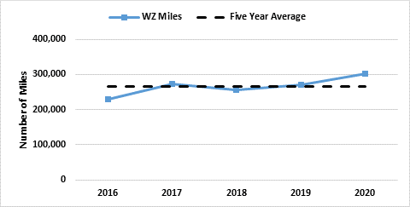
Source: FHWA
Figure 1. Graphic. Number of work zone miles.

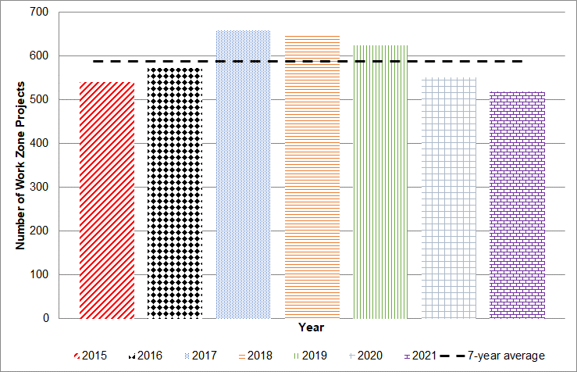
Source: FHWA
Figure 2. Graphic. Number of work zone projects.
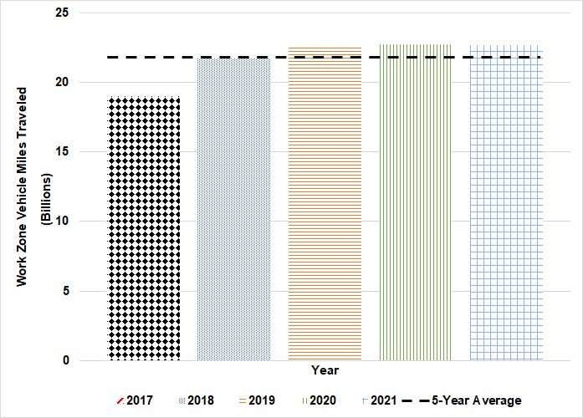
Source: FHWA
Figure 3. Graphic. Work zone VMT.

A.1.2 Examples of Work Zone Safety Data Charts
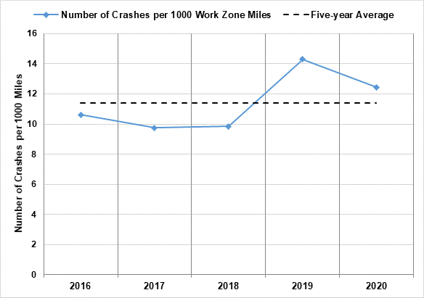
Source: FHWA
Figure 4. Graphic. Number of work zone crashes per thousand work zone miles.
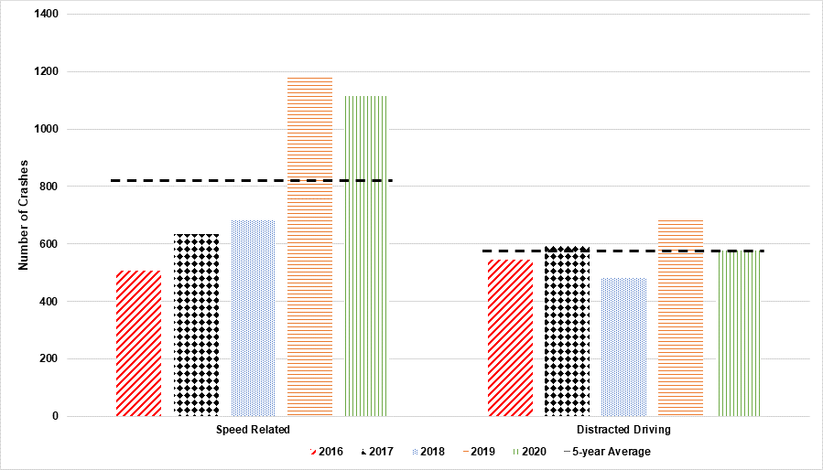
Source: FHWA
Figure 5. Graphic. Number of work zone crashes caused by speeding and distracted driving.
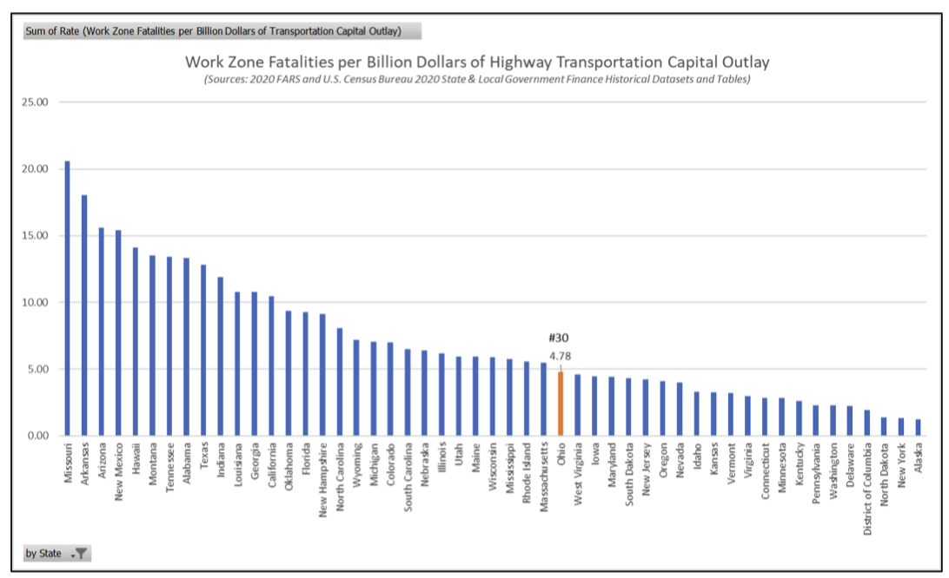
© 2022 Ohio DOT
Figure 6. Graphic. Work zone fatalities per billion dollars of transportation capital outlay.

A.1.3 Examples of Work Zone Mobility Data Charts
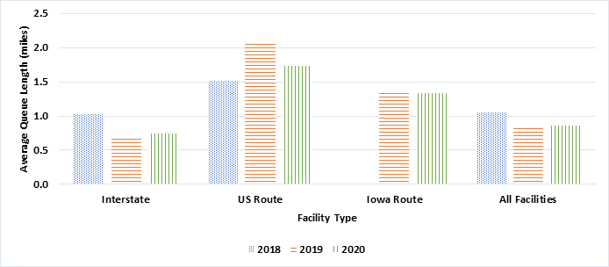
Source: FHWA
Figure 7. Graphic. Average work zone queue length at significant projects.

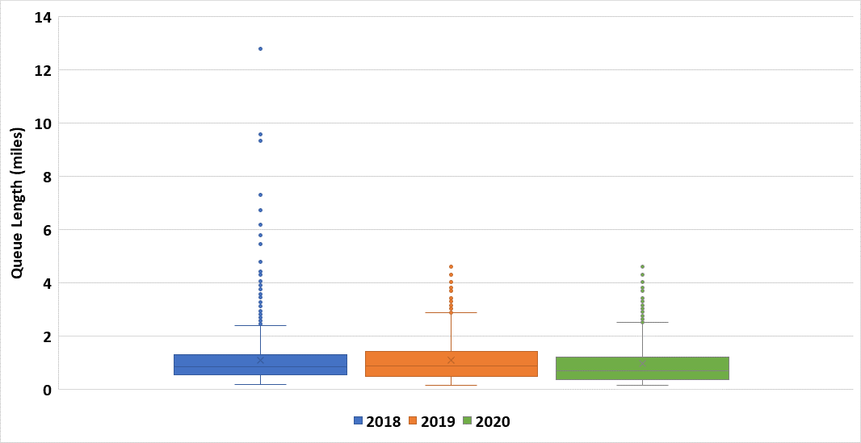
Source: FHWA
Figure 8. Graphic. Queue length distribution at significant projects.

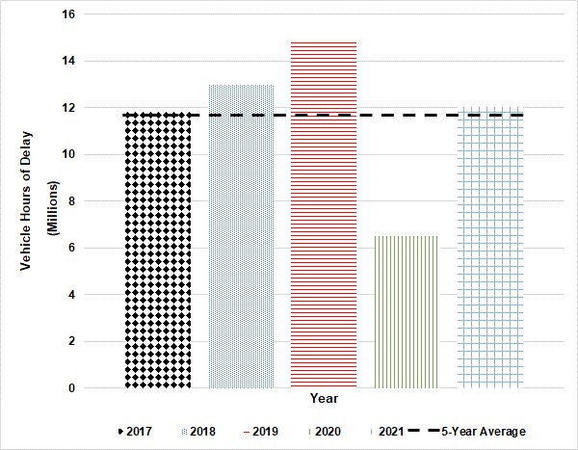
Source: FHWA
Figure 9. Graphic. Vehicle hours of delay.

A.1.4 Examples of Agency Efficiency Data Charts
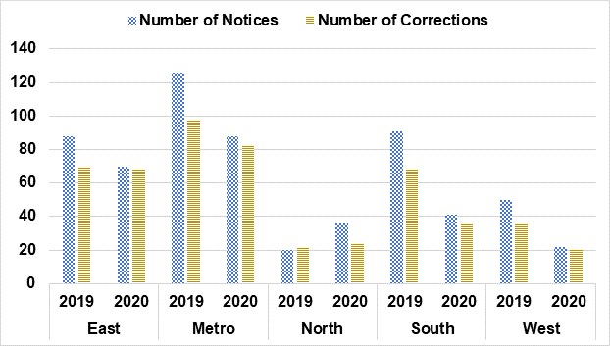
Source: FHWA
Figure 10. Graphic. Number of notices from work zone field inspections and resulting corrections.

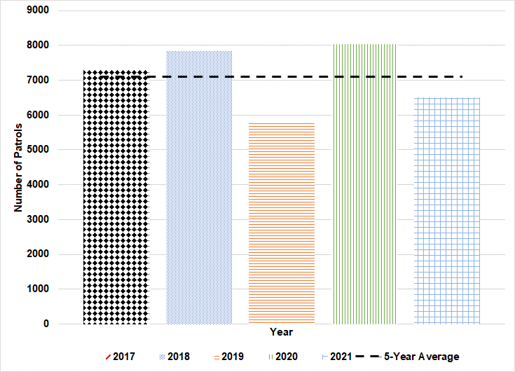
Source: FHWA
Figure 11. Graphic. Number of patrols in work zones.

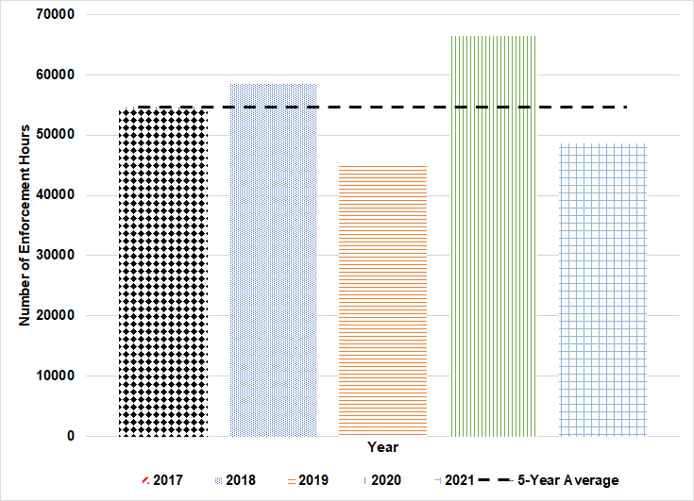
Source: FHWA
Figure 12. Graphic. Number of enforcement hours in work zones.

Table 10. Work zone traffic control strategies receiving an Exceptional or Acceptable rating for more than X% of field reviews.
Work Zone Traffic Control Strategy | Category | Interstate |  | U.S. and State Route |  | County Road |  | City Road
Work Zone Traffic Control Strategy | Category | 2018 | 2019 | 2018 | 2019 | 2018 | 2019 | 2018 | 2019
Lane Closure | Ballasting | ü | ü | ü | ü | ü | ü | ü | ü
Lane Closure | Cleanliness | ü | ü | ü | ü | ü | ü | ü | ü
Lane Closure | Crashworthiness | ü | ü | ü | ü | ü | ü | ü | ü
Lane Closure | Sheeting |  | ü | ü | ü |  |  | ü | ü
Lane Closure | Positive Closure | ü
Lane Closure | Location/Spacing | ü
Lane Closure | General Condition |  | ü | ü |  |  | ü
Lane Closure | Retroreflectivity |  |  | ü | ü | ü

Table 11. Work zone traffic control strategies receiving an Exceptional or Acceptable rating for more than X% of field reviews.
Work Zone Traffic Control Strategy | Category | Interstate |  | U.S. and State Route |  | County Road |  | City Road
Work Zone Traffic Control Strategy | Category | 2018 | 2019 | 2018 | 2019 | 2018 | 2019 | 2018 | 2019
Lane Closure | Location/Spacing |  | ü | ü | ü | ü | ü | ü | ü
Lane Closure | Positive Closure |  | ü | ü |  | ü | ü | ü | ü
Lane Closure | Proper Signage | ü | ü | ü | ü | ü | ü | ü | ü
Lane Closure | Retroreflectivity | ü
Lane Closure | Sheeting | ü |  |  |  | ü | ü
Lane Closure | General Condition |  |  | ü |  |  |  | ü | ü

Table 12. Annual TMP compliance audit by month of the year.
Audit Status | February | March | May | June | August | October | December | Total
Completed | 19 | 23 | 21 | 16 | 17 | 9 | 25 | 130
Not Completed | 1 | 0 | 0 | 0 | 0 | 0 | 0 | 1
Completion Percent | 95 | 100 | 100 | 100 | 100 | 100 | 100 | 99

Table 13. Annual TMP compliance audit by project type.
Audit Status | Resurfacing | Bridge | Paving | Grading | Signals | Other
Completed | 76 | 27 | 29 | 30 | 14 | 2
Not Completed | 0 | 0 | 0 | 0 | 1 | 0
Completion Percent | 95 | 100 | 100 | 100 | 100 | 100

